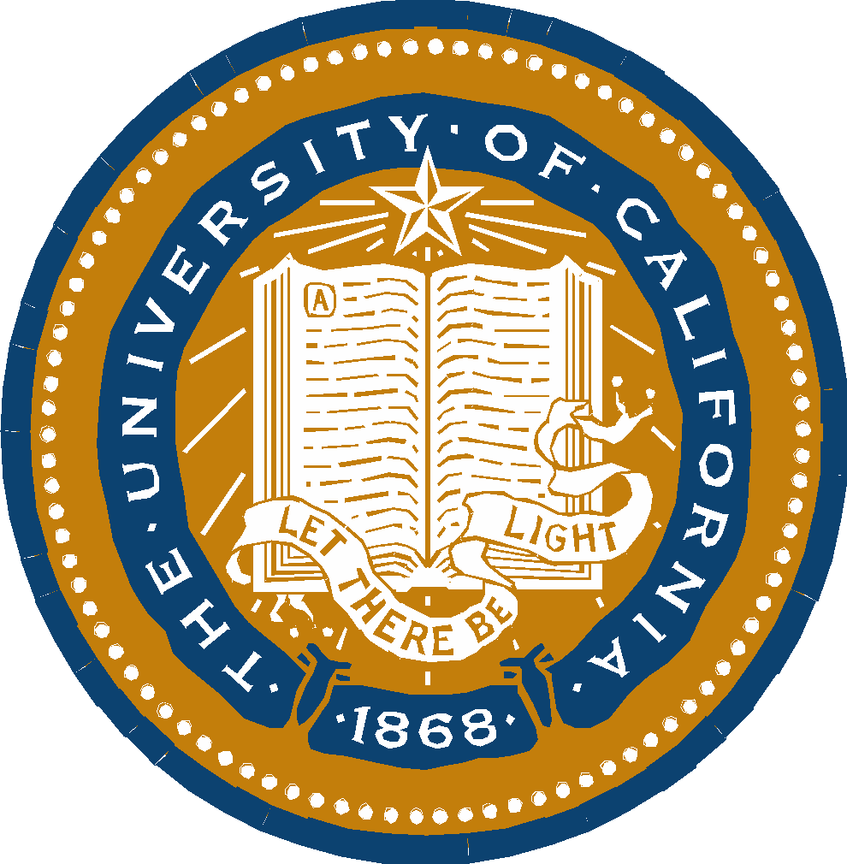
UNIVERSITY OF CALIFORNIA, BERKELEY
BERKELEY • DAVIS • IRVINE • LOS ANGELES • MERCED • RIVERSIDE • SAN DIEGO • SAN FRANCISCO |  | SANTA BARBARA • SANTA CRUZ
GRADUATE SCHOOL OF EDUCATION  2121 Berkeley Way, 4th Floor  BERKELEY, CALIFORNIA 94720-1670 |  | PHONE: (510) 643-6644

To: GSE Doctoral Students:
From: GSE Student Services
Re: Commencement Participation

This form is needed for doctoral students who would like to participate in this year’s Commencement but haven’t quite finished their degree. (Note: students who completed in December 2021 will automatically be sent an invitation to Commencement)

Please have your faculty adviser (dissertation chair) sign to indicate their approval of your participation in the School’s Commencement on May 20th, 2022. By signing, your faculty adviser confirms that you have either (please check one):

You’re on schedule to complete your degree in May 2022

You’re on schedule to complete your degree by August 12, 2022 (the summer filing deadline)

Doctoral Student Name (Please print) Dissertation Chair approval/signature

Please email his form to Jeanette Luong (luongj@berkeley.edu), no later than April 8th, 2022 in order to receive your invitation to Commencement.

